2.3 Make a People Plan for your venture.

4.1 Funding Options for an Entrepreneur

4.2 Create your Funding Plan

6.3 Create your Brand Name, Social Media Handler, and Logo; Identify your Right Channel.

Chapter 8 -

10.3 Scout for Board of Directors

11.1 Conclusion

LALA ENTERPRISES

[Greenhouse Best Management Practices (BMP) Manual | Center for Agriculture, Food, and the Environment (umass.edu)](https://ag.umass.edu/greenhouse-floriculture/greenhouse-best-management-practices-bmp-manual)

Contents:

*1.* ***Refining the Business Model, Product and Services***

***2. Business Planning***

*3****. Exploring ways to increase Revenue***

4. Funding the Growth / Scalability

*5.* ***Building the A Team***

***6. Creating Branding and Channel Strategy***

7. Leveraging Technologies and Available Platforms

8. Measuring your Progress

9. Legal Matters

10. Mentorship and Seeking Support

1. **Refining the Business Model, Product and Services**

1.1 Problems –

Insufficient Water Supply

Less Use of Modern Farming Equipment

Over Dependence on Traditional Crops

Poor Storage facility

Transportation problems

High Interest rate /No Stable Income

Unused Farming land

Old Farmer

Soil pollutants

1.2 current system

* Mono Croping.
* Fragmented Land.
* Most Farmers plant their crop during monsoon times an rest of the time land will be vacant.
* Some Land Owners are away From their land so the land will be vacant.
* Farmer(producer)) -> Middle man -> Mandi/Other Shop/Senior Man -> Mandi ->Auction->Company/Other owners-> Small shops->Customers.

1.3 our business model

Business description—What do you plan to do; why are

you starting the venture?

* Mixed Croping
* Use the Unused land
* We produce,We transport it to Mandi,We Sell in our own shop or tie up with the companies(Contracts)
* Search for the vacant field and Negotiating with its owner.
* If he is willing to work with us –
* We will first Register him in our group and give him his identity card
* We will provide him neccessary items depending on conditions and also human power to help him
* Money based on profit will be shared with him/Partiular amount of money is shared

* If he gives only his land and not willing to work
* We register him and give him his identity card
* We grow crops and sell but some amount of money will provided to him…Instead of wasting his vacant land this is better :)

Market analysis:Who will be your customers; what do

they want from you?

Farmers,Customers,Food Industries.

To Manage their lands,To provide them a stable income

1.4 Solution

Multiple Crops

Modernization in agriculture

Farmers Education is vital

Crop Insurance

Better Water Management

**Business Planning**

Section 1: Executive summary

* Search for the vacant field and Negotiating with its owner.
* If he is willing to work with us –
* We will first Register him in our group and give him his identity card
* We will provide him neccessary items depending on conditions and also human power to help him
* Money based on profit will be shared with him/Partiular amount of money is shared

Section 2: Business description

A. General description of the business

Its a agriculture/Farming related business which will benefit farmers,customers,Also some times government

B. Industry background

We will start our business by starting to plant the crops in our field,then others who have vacant land

C. Goals and potential of the business and milestones (if any)

International exporting of our yield/crops

Reducing National imports from other country eg vegetable oil

Bio Gas

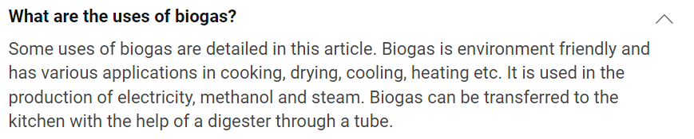

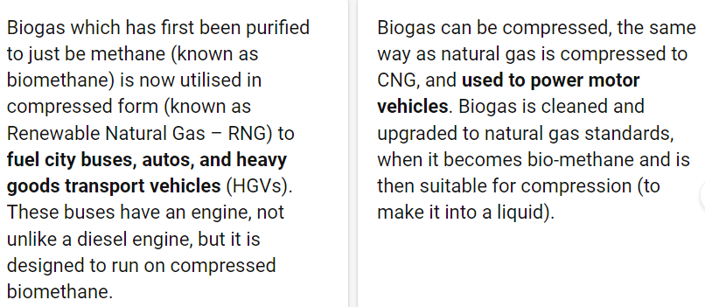

About Biogas:

* All the rotten vegetables and fruits are crushed into pieces and sent to conveyer belt
* 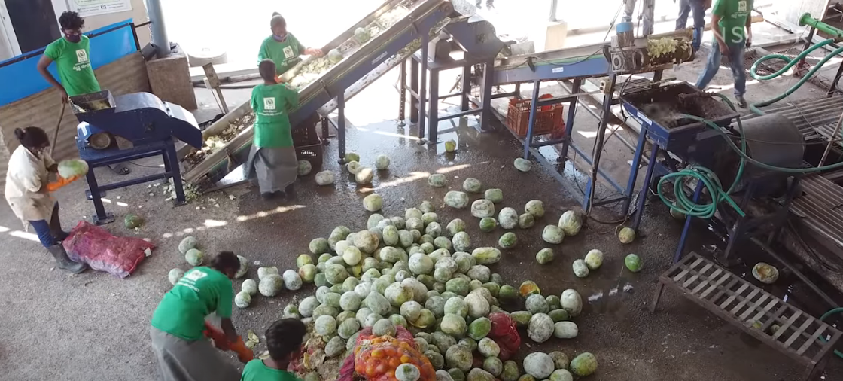
* 

Crushed vegetable pieces are supplied to huge containers





Bacteria giives out Methane & Co2

Burn Bio gas to obtain methane

Bio gas holder holds the methane before entering atmosphere while burning

Another by product of bio gas is fertilizer



D. Uniqueness of product or service

Quality vegetables with less chemicals

Fresh vegetables tobe sold

Residulas of bio gas to be used as fertilizer which enhances soil fertility

Soil testing

Concession for farmers who purchases crops from our shop but they have to show their id card

Section 3: Statement on sustainability

A. Performance measures

–DONO–

B. Market analysis

Section 4: Marketing

A. Research and analysis

1. Target market (customers) identified

* Our target are Vaccant Lands
* Rotten vegetables

2. Market size and trends

## Why You Need to Know Your Market Sizing & Trends

When you’re [developing a business plan](https://www.growthink.com/products/business-plan-template) to start or grow your company, you need to understand the size of your market and trends affecting it.

The market size confirms the market is big enough to warrant an investment of your time, and potentially investor/lender funding, into pursuing the opportunity. If the market is too small, you nor investors will not be able to get a reasonable return on your investment (which will dissuade [angel investors](https://www.growthink.com/angel-investors) and/or [VC funding](https://www.growthink.com/vc-funding)).

Likewise trends tell you if the market is increasing or decreasing, and how the market is changing. This can help you improve your strategy. For example, if you were starting a fitness center and you learned that there was a trend towards personal training services, it would be important for your strategy and plan to offer such options.

3. Competitive analysis- 5 force analysis

t is a broadly used model in business that refers to the five important factors that drive a firm's competitive position within an industry. By thinking through how each force affects you, and by identifying the strength and direction of each force, you can quickly assess the strength of the position and your ability to make a sustained profit in the industry.



5 forces

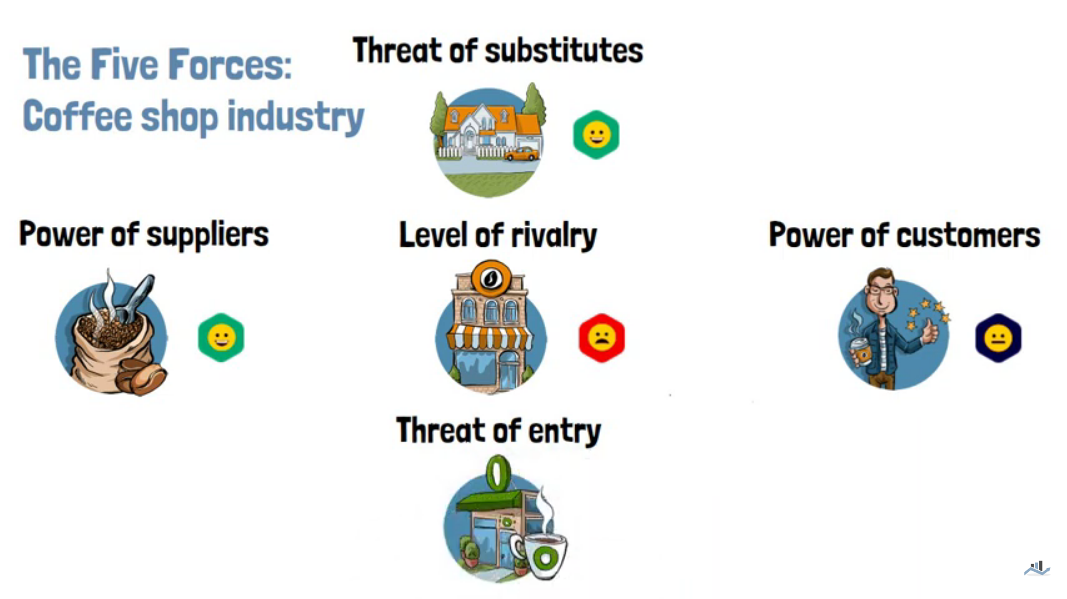

Level of rivalry –If similar company is there it makes the company less attractive so unique plam

Power of consumers – less prize & quality is where the consumers go to purchase

Power of suppliers — Good raw materials should be takes from suppliers

Threat of substitutes – Other farmers can grow vegetables and sell it or consumer can grow vegetables in their home or field

Threat of entry – new compiters may arise.

4. Estimated market share

B. Marketing plan

1. Market strategy – sales and distribution

* Farmer(producer)) -> Middle man -> Mandi/Other Shop/Senior Man -> Mandi ->Auction->Company/Other owners-> Small shops->Customers.
* Nkul choor explain mnple ya…..Onje baredh bacchind

2. Pricing

Depends on buy and sell for vegetables

The average price of methane around the world is **1.44 U.S. Dollar per litre**.

3. Advertising and promotions

Farmers are our advertisement because of the discount from the id card.

Google ads for farmers children to get know about our startups

Radio ads for those in village area

Paper ads

Meeting with farmers

Section 5: Management

Management team – key personnel

People plan

Legal structure – stock agreements,

In a stocking agreement, a **buyer agrees to purchase, and a supplier agrees to ship a certain amount of product throughout a set time**. This arrangement allows companies to manage their inventory to avoid overstocking or running out of a product.

Employment agreements,

This Employment Agreement i.e. terms and conditions of employment is a contract for use when an Indian business **hires a new employee**. It can be used for a range of different employment types, including full time, part-time and fixed term.

This Agreement sets out all the terms of employment, including **job duties, salary and benefits, work hours, confidentiality, annual leave** and various other key terms.

Ownership

Board of directors

A board of directors is referred to as a **group of individuals that represent the interest of the shareholders**. They are elected by the shareholders to oversee the activities of the organization, ensure that the assets are protected, and the shareholders receive a return on their investment.

Advisors,

https://www.feedough.com/who-is-a-business-advisor-10-types-of-advisors/

A business advisor works with the company very closely on their strategy and advice them on various aspects, especially on product development, marketing, and finances. These three dynamics are crucial to every business.

Consultants

‌A business consultant is an individual who works closely with business owners and managers to improve operations and efficiency. [Business consulting](https://www.accelo.com/industries/business-consulting/) includes helping to identify, address, and overcome obstacles to meeting a company’s goals.

## **What Businesses Need a Consultant?**

Nearly any business can benefit from a business consultant. Though some, like those below, might experience the most significant benefits.

* Startups can use consultants to complete planning and get a strong start.
* ‌Businesses that have been around for a while can benefit from a fresh perspective.
* ‌Companies starting new campaigns can benefit from a consultant’s research and expertise.
* ‌Businesses focused on growth can utilize a business consultant’s strategic skills.
* ‌Organizations that are not meeting their financial goals can hire a consultant to dig into their accounting.
* ‌Companies adding a new department can get help planning, setting up, and staffing that department.

<https://www.accelo.com/resources/blog/what-is-business-consulting-and-what-advantages-does-it-provide/>

Section 6: Financial

A. Financial forecast

1. Profit and loss

A profit and loss, or P&L, forecast is a projection of how much money you will bring in by selling products or services and how much profit you will make from these sales.

https://www.nolo.com/legal-encyclopedia/free-books/small-business-book/chapter14-2.html

2. Cash flow/Revenue source

Vegetable,Fruits & Crops

Bio gas

Natural Fertilizer

Farmers who purchases our product

3. Break-even analysis

A break even analysis tells you exactly what you need to sell to become profitable.

Break even analysis is a small business accounting process for determining at what point a company, or a new product or service, will be profitable.

https://www.shopify.com/blog/break-even-analysis

4. Cost controls

Cost control is the practice of identifying and reducing business expenses to increase profits, and it starts with the [budgeting](https://www.investopedia.com/terms/c/capitalbudgeting.asp) process. A business owner compares the company's actual financial results with the budgeted expectations, and if actual costs are higher than planned, management has the information it needs to take action.

https://www.accountingtools.com/articles/cost-control-definition-and-usage.html

5. Budgeting plans

A business budget provides an accurate picture of expenditures and revenues and should drive important business decisions such as whether to increase marketing, cut expenses, hire staff, purchase equipment, and improve efficiencies in other ways. It also outlines your organization's financial and operational goals, so it may be thought of as an action plan that helps you allocate resources, evaluate performances, and formulate plans.

B. Funding Sources

Antonys uncle who lives in foreign

Section 7 : Operations

Operations is the work of managing the inner workings of your business so it runs as efficiently as possible. Whether you make products, sell products, or provide services, every small business owner has to oversee the design and management of behind-the-scenes work.

Section 8 : Key metrics

Business metrics are a measure of a business or department’s activities and tasks. They are often measured over a period of time: daily, weekly, monthly, quarterly, or yearly. You can track them to determine ideal performance.

5 metrics are

1.Sales Revenue

2.Customer Acquazition cost

3.customer churn

4.customer engagement

5.customer satisfaction

<https://www.cyfe.com/blog/3-metrics-to-measure-business-performance/>

//

Competitor assessment—Who will you compete against;

* Government,other vegetable marts

what do these competitors offer?

* Low price for the farmers for the crops they grown

Marketing plan—How will you reach your customers?

Meetings,Ads,Our Teams

Operating plan—How do you plan to implement your idea?

Financial plan—How much money will it cost, and where

will you get the necessary funds?

20 lakh

Govenment fund at first ,later by selling crops.

Executive summary—What are the fundamentals of the

venture

//

**Exploring ways to increase Revenue**

1. Give Them Lower-Cost Add-On Options.
2. Fertilizers & Biogas which provide methane which will be used to produce electricity

### **Promote Surprise Pop-Up Sales**

* 1. Planned and promoted, or announced by surprise, pop-up sales have become all the rage these days, mostly driven by social media posts. The spontaneity of these sales may help keep customers coming back to your business or serving the dual role of keeping your customers regularly visiting your social media channels to find out when you’ll be having another sale—or even better if you’re having one right now.

1. **Extend to New Geographic Market**
   1. The sooner you discover that gaining a foothold in a new area is fruitful for your business, the better. Most of the time, [small businesses](https://www.deskera.com/blog/start-small-business-online) do not get out of their comfort zone, literally, and burden themselves with lower revenue. Realize that other areas may not have been covered by your contemporaries, after all.

#### **Increase or Decrease the prices based on the response**

* 1. Refining your pricing plan is a crucial step in increasing revenue. It also helps you to maintain your market share. Refining your pricing does not always mean lowering the prices; if you believe that the customers loved your products, you could also increase the costs to ultimately increase revenue. Upselling is an acceptable option when you have studied your market well. Alternatively, you can offer subscription plans to improve engagement and [decrease cart abandonment](https://www.deskera.com/blog/shopping-cart-abandonment).
  2. While a small price change may not impact things, but a more enormous price change could disrupt things. However, when you are attempting to revise your pricing, be mindful of the reactions it may generate. Understand that customers are sensitive to price change. Also, take into account which way things may go when the prices are increased or decreased.

#### **Work out Your Shipping Charges**

* 1. Free shipping or handling of products can work in favor of your sales, thereby increasing revenue. When you decide to increase your prices, try to introduce the aspect of free shipping. This could work well to offset the negativity generated by the price hike and stimulate more sales.

#### **Discounts and Price-slash**

* 1. Discounts could work wonders and be magnetic if implemented well. They inspire consumers to make a purchase by offering a an extraordinary buying opportunity. You could offer a variety of discounts and special product sections such as office supplies, school supplies, or on all the products with a varied discount on all of them.
  2. Discounts could be seasonal, conditional, quantity-based. Seasonal discounts are the ones you offer for a limited time, while the conditional ones are those presented on reconditioned products. Quantity-based discounts are like the Buy One Get One, for example.

#### **Create New Payment Methods**

* 1. Introducing payment systems that clients find more handy and comfortable may help you grow sales. Check your competitors' payment methods and select the relevant infrastructure resources necessary to implement the new modifications. Credit cards, for example, have found immense acceptance across the globe as an efficient payment method. Alternatively, you could have a cash exchange app or encrypted easy payment choices.

#### **Offering Delayed Payment Program**

* 1. Offering a delayed payment option, such as a store credit program or an installment plan, could boost sales. Customers prefer installment payment options since they represent smaller monthly payments instead of one huge amount.

### **Focus on Repeat Customers**

* 1. Instead of spending resources trying to gain new customers, small business should focus on upselling or cross-selling current customers. This is significantly more effective and cost-efficient as your current customers are already acquainted with your products and services and are therefore more likely to do business with you.
  2. A customer appreciation gesture such as special discounts and freebies will lead your past customers and clients to their next purchase. This gives them the impression that you went the extra mile for them because they are important to you.
  3. Connecting with your existing customers can also be an excellent way to acquire new customers to boost business growth. Since people are inclined to connect with others like them, giving existing customers a strong referral incentive can be a big win for your business.

**Funding the Growth / Scalability**

**As your business grows, your expenses may increase, requiring more financing.**

1. **Making growth more cost-efficient**
2. **Financing growth from profits**
3. **Attracting investors**
4. **Converting assets into growth**
5. **Finding financing**

[**https://www.fastcapital360.com/blog/funding-for-business-growth/**](https://www.fastcapital360.com/blog/funding-for-business-growth/)

**Building the A Team**

**characteristics and qualities of a successful team**

1. **Goal-oriented:** Teams need to share goals and results in order to work together. By being goal-oriented, your team will naturally lend itself to more collaborative efforts in order to reach that common purpose.

[PPT referral](https://www.geckoboard.com/blog/why-goal-focused-teams-are-essential-for-high-growth-companies/)

1. **Share accountability and ownership:** When teams share these aspects, they celebrate wins together and avoiding blaming any one individual for a problem. Everyone contributes and helps when a team member needs it.

[Share Accounttablity and ownership](https://fellow.app/blog/management/what-is-team-ownership/)

1. **Eager to learn:** Businesses change constantly and often rapidly. When your team is ready to embrace changes and learn something new, you'll have less trouble adopting best practices, new software, or meeting other business requirements.

## **steps to building a successful and effective team**

### **Set organization goals and start planning**

### Leading managers rely on goals for their hiring and team management efforts. These serve as guides to help you to start thinking about how to meet business needs. Clearly define your goals, such as landing more clients or improving the success of the next marketing campaign. Then, review past efforts and your current situation to see what you need to do to address these concerns.

### From there, you'll want to start making your plan to achieve these goals. Plans touch on the people, processes, equipment, and relationships needed to address all aspects of your goals. This will help you see any gaps or adjustments you need to make.

### **Define the roles within your team**

* 1. Creating your plan will give you a list of business needs. Address them by defining who’s responsible for each aspect of your goal. These assignments translate to the specific roles your team needs. If you have an existing team, see who can fill each role and adjust assignments accordingly. If you're hiring, look for skill sets to meet each role and the experience required to perform those tasks.
  2. Defining roles and responsibilities can make an enormous difference in your team's success because everyone knows what’s required of them. People can tell if they're meeting goals and tasks, and will know who to ask for help when the need arises. Roles also help your staff understand how their performance will be evaluated, and meeting those expectations can improve morale.

### **Maximize the skills of your team member**

* 1. A strong leader knows and utilizes the skills and strengths of each team member. Your goal is to do this with each employee individually while also identifying where people have complementary skills. Review the capabilities of each person on your team, including their strengths and weaknesses. Giving someone backup or a partner who excels where they struggle can keep morale high and limit workplace frustration.
  2. Your employees want to be on successful teams. Providing this help empowers them to do their best while also minimizing your turnover risks.

### **Allow your team to take risks and experiment**

* 1. Taking risks helps your team grow and find innovative solutions to existing problems. You may uncover something that works better or is more affordable than current methods, or even unlock a new area of business. Or you might not.
  2. No risk or experiment guarantees positive results. As a manager, your job is to guide these efforts to keep them reasonable for your company and protect the bottom line. However, when you allow someone to take a risk, you'll want to reward that behavior regardless of the outcome. Encourage them so that people feel confident to try something new. You'll also get to see how different employees drive their work when put in charge, reinforcing your understanding of their strengths and weaknesses.

1. **Promote individual development**
   1. It's very likely that your team wants to continue to grow in their roles, capabilities, and career. Many will find life satisfaction in their work. Foster that by encouraging them to take the next steps in their career and develop as individuals, not just as a person at your company.
      1. Employee development can also help your team gain the skills the organization needs to continue on its growth trajectory. As a manager, part of improving your role and skill set is laying the foundation for individual development. Some methods to consider include:
      2. Offer professional training on software, tools, and best practices
      3. Bring in coaches to train leaders on [management skills](https://www.upwork.com/resources/manager-skills-resume)
      4. Encourage people from different teams to work together and build cross-department relationships
      5. Give employees time to pursue outside education opportunities, such as relevant certificates
      6. Have workshops on soft skills, such as [communication, relationship building, collaboration, and trust](https://www.upwork.com/resources/guide-behavior-driven-development)

### **Avoid micromanagement**

* 1. Constantly staring over your team's shoulder can set them on edge or make them more worried about you than about completing their tasks. Looking at every email, listening to all calls, and interjecting at any moment will prevent them from feeling trusted and can reduce both effectiveness and your turnover rate.
  2. Allow people the freedom and self-determination they need to get their work done, based on what's appropriate for the role. Someone working in a kitchen has specific tasks that must be done in a certain order, for example, but your sales team's goal is often to hit a quota, which gives flexibility in when and how they sell.
  3. Let your team complete tasks with some autonomy and have regular meetings or requirements for people to report that status. Autonomy is a desired workplace perk and can help your team [deliver more value to your organization](https://www.forbes.com/sites/stanphelps/2019/09/24/if-you-love-your-employees-set-them-free-autonomy-is-key-to-employee-engagement/?sh=1ed81da68e68).
  4. As an added benefit, this will free you up to finish your own projects more quickly and effectively.

### **Establish strong leadership**

* 1. Your ultimate goal as a manager is to be a good, strong leader. That can mean many different things to different people, so let's set a quick definition. By strong leadership, we're talking about the ability to bring your team together to accomplish unified goals while inspiring them to take their personal careers to new heights.
  2. Strong leaders have more effective teams, [better communication](https://www.upwork.com/resources/ideas-improving-communication-distributed-team), and are able to resolve issues more quickly. You're not only leading by example, but you're helping people to enjoy their work and take pride in it, leading to improved productivity.

### **Create a team culture**

* 1. Your team will be more effective when they share a vision of what they want to accomplish. Getting everyone on the same page for goals and how they are achieved creates room for cooperation and planning. Creating a "big picture" helps everyone understand what you're striving to do and enables them to take risks to achieve it.
  2. This vision is a core component of your culture. Company culture is a shared set of goals, ideals, and attitudes. It defines what you want your team to achieve, the methods to meet those goals, and how people within the team will behave.

### **Communicate frequently and effectively**

1. Every other step in our list is [built on the foundation of communication](https://www.upwork.com/resources/communication-is-key/). We've saved it for last because it's always good to remind yourself that you need to communicate clearly and frequently.
2. Effective communication sets goals for your team, helps them feel encouraged and can identify issues before they become big problems. Something as simple as a Slack message in the morning asking how a project is going or if there's a bottleneck can help you tackle an issue and remind your team that you’re there to support their efforts.
3. Clear communication is also how you ensure that your positivity and celebration are received. Think about how you can thank someone directly and how you can communicate it to the whole team. The nuances you use for that whole-team discussion will help you understand how to frame concerns as well. Instead of blaming someone for taking a risk, you can get the team together to discuss what happened and how to make improvements for next time.

Reference :[Click Here](https://www.upwork.com/resources/how-to-build-a-successful-team)

Channel Strategy

Specific types of channels include:

* Email
* Social media
* Your website
* Content marketing
* SEO
* Direct mail
* TV ads
* Print ads
* Pay-per-click (PPC) ads
* Affiliate marketing
* Influencers
* Brand ambassadors
* Word-of-mouth

**Creating Branding and Channel Strategy :**

“A brand is a name, term, design, symbol, or any other feature that identifies one seller’s good or service as distinct from those of other sellers”

In very simple words, a product is what you sell, a brand is the perceived image of the product you sell, and branding is the strategy to create that image.

### **Retail**

A company that uses retail as a distribution channel may sell its products directly to consumers in-store, online or by phone. It may also use a third-party online marketplace to sell its goods. Some benefits of using retail as a distribution channel include:

* More control over how to reach consumers
* Ability to gather better consumer data from sales
* A more personal connection with consumers
* Higher profit margin than wholesalers
* More control over your brand identity

### **Wholesale**

Companies that sell their products in bulk to different outlets or retailers use the wholesale distribution channel. These outlets and retailers then resell the products to consumers. Companies that use the wholesale distribution channel typically sell their products at a lower price because bulk orders reduce transportation and labor costs. Some benefits of using the wholesale distribution channel include:

* Ability to use drop-shipping, which decreases the space needed to store inventory
* Increased brand awareness
* Accelerated growth and access to global expansion

**Leveraging Technologies and Available Platforms**

Data analytics for

Testing soil

Weather forecast

High yield seeds

[Agriculture 4.0 – The Future Of Farming Technology (oliverwyman.com)](https://www.oliverwyman.com/content/dam/oliver-wyman/v2/publications/2021/apr/agriculture-4-0-the-future-of-farming-technology.pdf)

**Measuring your Progress**

[**8 Steps to Evaluate Your Business Progress | Solopreneur Solutions (solopreneursllc.com)**](https://solopreneursllc.com/8-questions-to-evaluate-your-business-progress/)**\**

[**4-BenchmarkingInternLores.pdf (fao.org)**](https://www.fao.org/uploads/media/4-BenchmarkingInternLores.pdf)

[**4 Useful Tools to Evaluate Farm Profitability and Financial Performance - FINPACK (umn.edu)**](https://finpack.umn.edu/news/4-useful-tools-to-evaluate-farm-profitability-and-financial-performance/)

**Legal Matters:**

Illi kelav points haktene nodu

[**Legal Requirements for Starting a Business in India | Ahlawat Associates**](https://www.ahlawatassociates.com/blog/legal-requirements-for-starting-a-business-in-india/)

[**LEGAL REQUIREMENTS TO START A BUSINESS IN INDIA | GLC & PARTNERS**](https://www.glc.law/blog/legal-requirements-to-start-a-business-in-india/)

**Before starting a business, entrepreneurs must be aware of the laws governing the market and business. The following are the legal requirements that required to start a business in India.**

**Registration of a business entity: The first step is deciding the business structure and registering it. Some of the common business entities are Sole Proprietorship, One Person** [**Company**](https://www.startupindia.gov.in/content/sih/en/registration.html)**, Limited Liability Partnership, Partnership Firm, Private limited company, and Public limited company.**

**Name: One of the most important steps is deciding the name of the business as it reflects the vision of the business. Check to see if the name you selected hasn’t been claimed by another entity.**

**Founders Agreement: Creating a founder’s agreement containing all the details regarding founding members of a business is a solid foundation of the business. As a result, the document serves as a contract that legally establishes the founders’ and company’s rights, ownership, obligations, dispute resolution, and other aspects.**

**Documents: The first step is to ensure that all of the necessary documents for registration are in order. Setting up a business in India necessitates a plethora of legal requirements and documentation. Important documents that are required includes, Digital Signature Certificate, Director Identification Number, Registration on the MCA Portal, Certificate of Incorporation, Commencement of Business Certificate and documents of the company such as Address, PAN number, GST registration, ESIC registration, ROC registration, Professional Tax registration, etc.,**

**Legal licenses and registrations: To conduct and run the business, there are few registrations and licenses required. Some of the general registrations include Shops and Establishments License, Permanent Account Number, GST registration, Income Tax registration, Bank Account, etc., some of the specialized registrations examples include, FSSAI License to start a food business, IEC code to do import and export business, Halal registration in case of dealing with such goods and other licenses involved for respective types of business fields.**

**Taxation laws: In any kind of business, taxes play a crucial role. There are respective local taxes, state taxes and central tax that apply to different business sectors, therefore, knowledge of the tax regime with respect to one’s business sector is very important. For example, there are certain tax exemptions and waivers for startups under various government schemes and initiatives in India. Such exemptions may be used for the benefit of the organization. In terms of business accounting, it is best practice for a company to keep adequate books of accounts and audit them on a regular basis to ensure that all applicable and relevant accounting and taxation rules are adhered to.**

**Labour laws: Labour laws regulate minimum wages, maternity benefits, gratuity and PF payments, laws relating to sexual harassment at workplace, etc., and every business must ensure that the labour laws are strictly adhered to for smooth and successful running of the business.**

**Intellectual Property: Protecting the Intellectual Property rights are a very important aspect for enhancement of the business. Any new inventions, symbols, logos, brand name, etc., is to be registered which in turn helps in the recognition of the business among the competitors and enhances the Goodwill of the company.**

**Business policy: Another step that can help a business succeed is to develop a proper business policy. It’s something that keeps both employees and management on track. This makes achieving the desired targeted growth more easier.**

**Insurance: It is always safest to get insurance to safeguard your business from other potential threats.** [**Business**](https://www.glc.law/practice-areas/startups-and-emerging-companies/) **insurance can help one to protect the assets of your company. Unemployment and disability insurance are two types of insurance that are required by law. General liability insurance, product liability insurance, and commercial property insurance are just a few examples.**

**Legal compliance is critical for any organization and understanding and adhering to all the applicable laws ensures smooth running of the business of the company.**

* If we are planting in our land & selling in our shop then permission from gram panchayat is needed requires 2-3 days to get licence
* If we take others shop as rent then sign from taluq panchayat and door number of the person’s shop must be mentioned in the licence

**While making a deal:**

Capacity to contract: The parties to the real estate lease contract must have the legal capacity to enter into the agreement. Age, mental competency, and other issues are considered. A minor, which is a person considered 18 years of age or younger, could not enter into a lease. Also, if a person with documented mental competency issues enters into a lease, it would be considered invalid.

Legal objectives: The purposes of the lease must be legal. If the property to be leased is used for illegal purposes, the lease would be invalid.

Offer and acceptance: All terms of the contract must be agreed upon by both parties. The owner or landlord would offer these terms to the tenant and the tenant would accept them, signified by their signatures to the lease.

Consideration: Normally, consideration for a valid lease contract is in the form of rental payment(s). However, it could be in some other form, such as a trade of labor or property improvements for tenancy. Rent is normally fixed for the life of the lease and cannot be changed unless agreed to in writing by both parties.

Legal Guide To The Requirements And Formalities Involved In Starting A Business

From forming a founders’ agreement to protecting intellectual property, entrepreneurs must be aware and updated about the latest laws governing their business and market. Some of these crucial legal formalities that entrepreneurs in India should be aware of before setting up a business venture are:

1)Deciding on a business name

Once you decide which business structure fulfils your purpose, you are then required to choose a business name that reflects your venture’s ideology and make sure it is not already claimed by some other entity. For this, you will have to choose an entity name that safeguards your entity at the state level, a trademark that safeguards your entity at the national level and a domain name that gives life to your venture online.

2)Creation of a founder’s agreement

A Founder’s Agreement is a document that has important details about the founding members of a venture/business. The document thus acts as an agreement that legally establishes the rights, ownership, responsibilities, dispute resolution and other terms executed between the founders and the company.

Therefore, having a well-drafted Founders Agreement with all necessary details forms a solid foundation for the journey of a business. The agreement can also act as the go-to guide in the case of any disagreements arises.

3)Acquire all the legal licenses and registrations

Once the Founder’s Agreement is drafted, the authorization to do business is what’s required next. The authorizations come in the form of legal licenses and registrations. While some of them are general and are required for all kinds of businesses other are specialized and are additionally required for certain kinds of businesses. Example Include:

General registrations:

GST registration

Permanent Account Number

Tax Account Number

Bank Account

Shop and Establishments license (License for physical premises to the commercial establishment)

Specialized registrations:

IEC code (To do import and export business)

FSSAI License (To start a food business)

Kosher Registration (To deal with kosher goods)

Halal Registration (To deal with Halal goods)

Other licenses for other types of businesses

4)Be acquainted with the relevant tax regime and accounting norms

Taxes are an important part of every business. And when it comes to India, there are a wide variety of taxes, such as, central tax, state tax and even local taxes that may apply to some businesses. Since different business and operating sectors attract different taxes, knowing the relevant text regime well in advance can be quite useful.

There are also various schemes and initiatives such as the Central Government’s ‘Startup India’ initiatives that aim to promote startups, via various exemptions and tax holidays.

Good knowledge of such initiatives and pro-startup regulations can also come in handy. A startup can also avail of income tax exemption for 3 years as well as tax exemptions from capital gains and investments above the Fair Market Value. Therefore, holistic knowledge of taxation can prove to be fruitful for growth and even expansion.

As far as business accounting is concerned, it is good practice for a business to maintain proper books of accounts and audit them from time to time ensuring that relevant accounting and taxation rules are being followed.

For this, having a sound payment and invoicing system can help ensure a clear accounting system.

5)Be acquaint with labour laws

Labour laws are part of every organization, small or big. When your venture is recognized as a company that hires people, your organization is subject to several labour laws regardless of its scale. These laws govern crucial issues such as minimum wages, gratuity, PF payment, weekly holidays, maternity benefits, sexual harassment, and payment of bonus among other key areas.

6)Safeguard Intellectual Property

Intellectual property is a vital part of most businesses today, especially for tech-centric ventures. Be it codes, algorithms or even research findings, all these are some of the common intellectual property owned by an organization.

The creation and the subsequent protection of these intellectual properties are central to the effective growth of every innovating venture. Therefore, legal know-how in relation to IPR laws can come in handy at every stage of a venture’s journey.

Startups can also take the advantage of the Scheme for Startups Intellectual Property Protection (SIPP) under the Startup India initiative, that nurtures and mentor innovative and emerging technologies and help in its due protection and commercialization.

7)Creating a proper business policy

Creating a proper business policy is another step that can take a venture towards success. It is something that keeps the employees as well as the management focused. This way desired targeted growth can be easily achieved.

8)Get business insurance of your choice

Business insurance can safeguard your venture in cases where the personal liability protections of your venture aren’t enough. Insurance can protect not just your individual assets, but your business’s assets too. Some types of insurances such as unemployment and disability insurance are even compulsory by law.

It’s also a wise decision to have avail insurance that protects your startup from other potential risks. Some of these include general liability insurance, product liability insurance, commercial property insurance etc.

9)Have a clear idea about the mode of winding up

Winding up a company is a difficult call to make. When a company decides to shut down, all the stakeholders, from vendors to investors are needed to be informed in advance making the entire procedure a task that needs to be thoroughly planned and executed.

From the legal standpoint, there are three ways to wind up:

Court or Tribunal Route

Voluntary Closure/ Fast Track Exit Mode

Documents Required For Starting A Business In India

The first step to establish a business in India is to make sure that the documents required for registration are complete. Any error in documentation can put all the efforts in vain.

There are a lot of legal formalities and documentation that are necessary for setting up a business in India. The following are the most crucial documents required:

Digital Signature Certificate (DSC)

Director Identification Number (DIN)

Registration on the MCA Portal

Certificate of Incorporation

Commencement of Business Certificate

Along with these documents, you will also need documents that officially represent your business’s company’s office address, PAN number, GST registration, ROC registration, Professional Tax registration, Provident Fund registration, and ESIC registration.

Various startup documents are also required to be arranged before starting a startup in India. Below is the list of those documents:

#1 Bylaws

Bylaws act as sets of rules. They make sure that every startup functions smoothly with correctness and gives voice to everyone involved in the working.

#2 Memorandum of Understanding

It consists of all formal conversations you have made with suppliers, potential partners and others involved in the business. An MOU is a good way to lay the terms of a project or relationship between employees and employers in writing.

#3 Licensing Agreement

A licensing agreement is entered by two parties basically in scenarios such as maintaining possession of a product or control over an asset and another company/ individual desiring to use the asset.

#4 Non-Disclosure Agreement

It is the first thing that you are required to reach out for when dealing with any client or investor. It ensures that the privacy of your company, as well as that of the other party, remains protected.

Aside from aforesaid documents, other startup documents that may assist you in beginning a startup in India are the Intellectual Property agreement, Employment agreement, Non-compete agreement etc.

Conclusion

Starting a business in India can be daunting, especially with all the legal requirements that you are required to follow. However, now that you know about them, you are not just ready to start it but ready to make it a success. Adhering to legal formalities is very important for any business; knowledge and compliance to applicable laws is the initial step to ensure smooth business operations.

The best ways to ensure that your company is always safe and does not face legal complications and consequences is by hiring professional legal counsel to provide advice, oversee and maintain legal records.

Frequently Asked Questions (FAQs)

1. Which type of business is easiest to start?

A service business is one of the easiest businesses to start, especially when you are a beginner. A business that sells a service, like skill, expertise, or labour, can be considered as a service business.

2. What is the first thing to do before starting any business activity?

The best steps to take when trying to start a business are looking at the legal aspects of the sector, analysing the competitors, and evaluating your finances and business licenses and permissions.

3. What amount of capital should be introduced for starting a business?

The amount of capital depends on the activity and its scale. It differs from small and medium scale businesses to wholesale and retail businesses. The best way to decide the appropriate amount is to first analyse the future expenses and requirements.

Also, one has to fulfil the minimum requirement of capital based on the organization structure chosen.

4. What aspects should be considered while choosing the right business entity?

To choose the right business structure, the first aspect is to decide if there is any business partner or not. Those who wish to be sole owners opt for Sole Proprietorship and OPC whereas other structures can be established with partners.

Next thing is to decide about the capital requirement. For businesses with a large capital requirement, corporate structures are beneficial. Apart from all other pre-registration aspects, one must not forget to consider the post-registration aspects, tax liabilities, and compliance matters.

5. Which steps should be taken to register a business in India?

To register a business in India, the promoters or owners are required to finalize their business activities and capital requirements first. Based on aspects such as the association of partnership, capital requirements, types of activities, etc. the appropriate business structure is chosen.

**Mentorship and Seeking Support**

* Mentors can be key to your business’s success by giving you insights from those who did it before you.
* You'll receive guidance based on real-world experience, connections to other advisors, and physical resources from your mentors to aid in your development.
* Aim to give as much as you receive, whether by picking up the tab or providing new strategies your mentor doesn't have experience in.

13 banks which provide agriculture loans

<https://nextwhatbusiness.com/agricultural-loan-providers/>

Government scheme for startups—--Start up India Scheme(70 lakhs=20 lakh grants+50 lakh debt)



## **Eligibility for Registration under Startup India**

The above-mentioned company(s) are required to meet the following eligibility criteria, to be able to avail the benefits under the scheme:

* The company must be a private limited company or a limited liability partnership.
* The firm must have obtained approval from the Department of Industrial Policy and Promotion (DIPP).
* It must have a recommendation letter by an incubation.
* The firm must provide innovative schemes or products.
* It should be a new firm and not older than five years.
* The total turnover of the company should not exceed 25 crores.
* It should not be a result of any business already in existence, i.e., a company incorporated as a result of the scheme of rearrangement

## **Benefits of Startup India Scheme**

### **Tax Exemption**

In a wonderful movie, the startups registered under the Startup India scheme are exempted from tax. This exemption is provided for a period of the initial three years. Any [investment](https://digest.myhq.in/active-angel-investors-india/) which is made by [incubators](https://digest.myhq.in/list-startup-incubators-in-india/) of higher value than the market price is exempted.

Further, investments made by angel investors are also exempted under the scheme. A tax holiday for the first three years or reaching a certain threshold limit means, that the startup can completely utilize the revenues for business development purposes only.

### **Networking Options**

Under the scheme, startups get opportunities to meet other startup stakeholders at a particular place and time. These meetings are conducted as fests. These fests are conducted twice, annually.

The fests are conducted on both national and international levels. This provides startups with a great opportunity to not only seek funding but also grow and develop by looking at other startups. It also provides them with a broader perspective with their day to day activities.

## **Business Loans for Startups by the Indian Government**

### **Bank Credit Facilitation Scheme**

* 1. Headed by the National Small Industries Corporation (NSIC)
  2. The NSIC has partnered with various banks to [provide loans to the MSME](https://www.bankbazaar.com/personal-loan/msme-loan.html) units.
  3. The repayment tenure of the scheme ranges between 5 years and 7 years but in special cases, it can be extended up to 11 years.

### **Pradhan Mantri Mudra Yojana (PMMY)**

* 1. Launched in 2015, this scheme is headed by the Micro Units Development and Refinance Agency (MUDRA)
  2. it aims at offering loans to all kinds of manufacturing, trading, and service sector activities.
  3. he scheme offers loan under three categories – Shishu, Kishor, and Tarun in amounts ranging between Rs.50,000 and Rs.10 lakh
  4. The [Mudra loan](https://www.bankbazaar.com/personal-loan/mudra-loan.html) can be availed by artisans, shopkeepers, vegetable vendors, machine operators, repair shops, etc.

### **Sustainable Finance Scheme**

* 1. Launched in April 2016 and headed by SIDBI.
  2. This scheme extends loans to enterprises in manufacturing, trading, or services. Under this scheme, loans ranging between Rs.10 lakh and Rs.1 crore can be availed.
  3. The repayment of loans taken under this scheme can be done in seven years while the maximum moratorium period allowed is 18 months.

[Bank Loan for Kisan Credit Card](https://www.creditmantri.com/article-which-bank-is-best-for-agriculture-loan-in-india/)

[Agriculture Farm Business Plan – Financial Plan Template — Bplans](https://www.bplans.com/agriculture-farm-business-plan/financial-plan/)